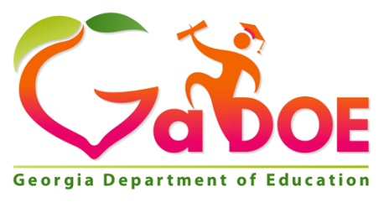 | SLDS News  2014-2015 Milestones  EOG & EOC |  | SLDS was built for you,  Help us make it better.
Subscribe | Contact SLDS | Recent Updates | Help & Training | Request FREE Training

New Domain view for Milestones available in SLDS
The DOE has been diligently working to display the NEW Milestones' Domain displays inside of SLDS. Click here for more detailed information regarding the NEW display. The detailed information also shows the new displays found on the Student Profile page.
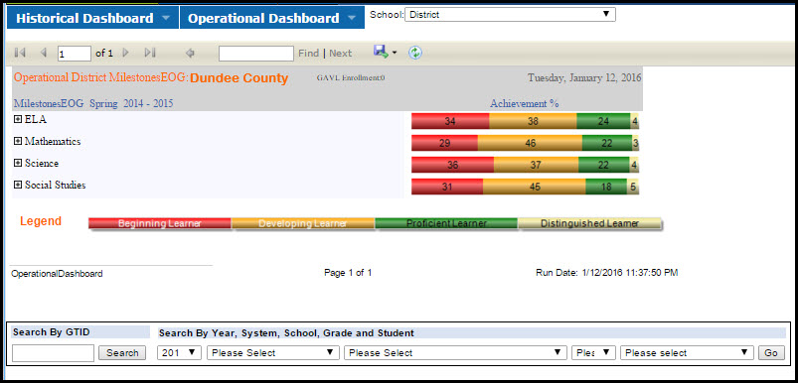

The below samples from the District Level "Operational Dashboard" are also how the display works from the Teacher's Dashboard using the Statewide Classroom Performance tool.
"The first sample shows the NEW ELA test breakdown, which includes the ‘Reading Status’ (Below Grade Level or Grade Level or Above) based on how the student performed on the reading and vocabulary items included on the test. This is followed by the rubric scores awarded for the two writing components of the test (narrative – worth 4 points and the extended writing – worth 7 points using two rubrics)." (from Assessment & Accountability)
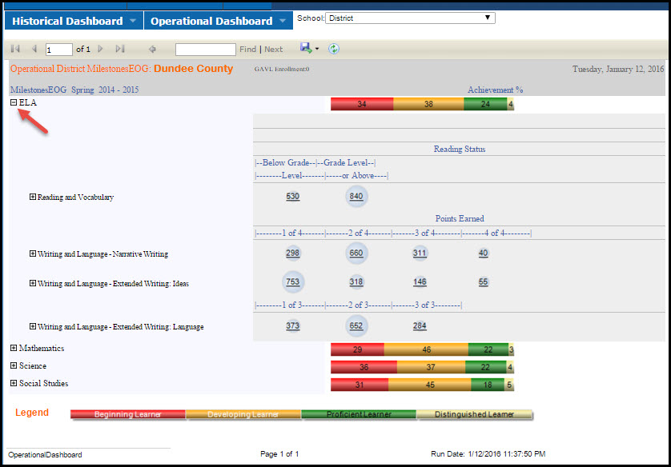

This second sample is showing the NEW Social Studies Domain break down. This is the same view for Math and Science. It displays the "Mastery Category" levels of "Remediate, Monitor, and Accelerate."
"The domain classification indicates whether the student would have been proficient on the overall test if he/she performed on the overall test as he/she performed on the items in the domain. If it is unlikely the student would have been proficient, remediation is needed. If it is possible, but equally possible the student may not have been proficient, learning should be monitored. And if it is likely the student would have been proficient, then learning should be accelerated." (from Assessment & Accountability)
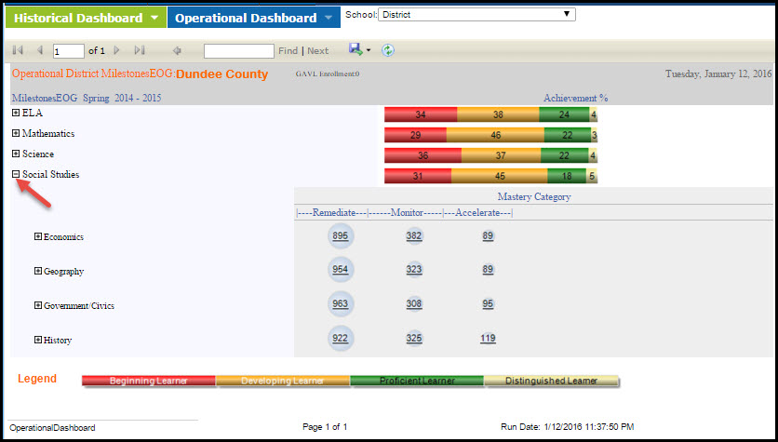
We anticipate the 2015 Spring & Summer EOCs to be available in SLDS by February 1st.

