

**What is Family Engagement?**

Family Engagement means the participation of parents and family members in regular, two-way, and meaningful communication involving student academic learning and other school activities, including ensuring:

(A) That parents play an integral role in assisting their child’s learning.

(B) That parents are encouraged to be actively involved in their child’s education.

(C) That parents are full partners in their child’s education and are included, as appropriate, in decision-making and on advisory committees to assist in the education of their child.

(D) The carrying out of other activities, such as those described in Section 1116 of the ESSA.

In support of strengthening student academic achievement, the Murray County Schools (MCS) has developed this parent and family engagement policy that establishes the district’s expectations and objectives for meaningful family engagement and guides the strategies and resources that strengthen school and parent partnerships in the district’s Title I schools. This plan will describe MCS’s commitment to engage families in the education of their children and to build the capacity in its Title I schools to implement family engagement strategies and activities designed to achieve the district and student academic achievement goals.

When schools, families, and communities work together to support learning, children tend to do better in school, stay in school longer and enjoy school more. Title I, Part A provides for substantive family engagement at every level of the program, such as in the development and implementation of the district and school plan, and in carrying out the district and school improvement provisions. Section 1116 of the Every Student Succeeds Act (ESSA) contains the primary Title I, Part A requirements for schools and school systems to involve parents and family members in their children’s education. Consistent with Section 1116, the MCS will work with its Title I schools to ensure that the required school-level parent and family engagement policies meet the requirements of Section 1116(b) and each include, as a component, a school-parent compact consistent with Section 1116(d) of the ESSA.

**About the Parent and Family Engagement Policy**

2017–2018

Revised June 15, 2017

1006 Green Road

Chatsworth, GA 30705

murray.k12.ga.us

(123) 456-7890

**Murray County Schools**

**Parent and Family Engagement Policy**

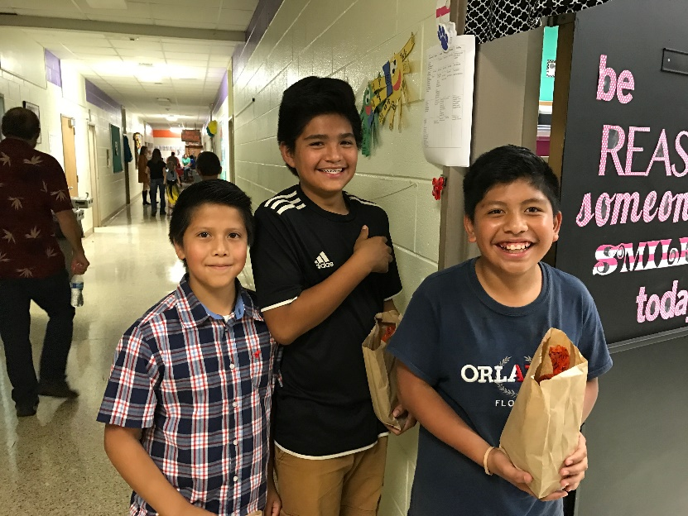

**Strengthening Our School**

MCS will provide opportunities for Title I teachers and administrators to attend Title I Technical Assistance meetings that include training on programs, activities, and strategies aligned to academic progress and student achievement and focusing on engaging Title I parents. The district will provide updated community resources to assist schools in meeting the needs of Title I parents.

In the spring, school level Title I Coordinators and district personnel will met to review the Parent Climate Survey to discuss goal setting for Parent Involvement practices. Parents will also be given opportunities throughout the school year to discuss their needs and to evaluate programs.

**Reservation of Funds**

MCS will reserve 1 percent from the total amount of Title I funds it receives in FY18 to carry out the parent and family engagement requirements listed in this policy and as described in Section 1116 of the ESSA. Furthermore, MCS will distribute 90 percent of the amount reserved to Title I schools to support their local-level family engagement programs and activities. The district will provide clear guidance and communication to assist each Title I school in developing an adequate family engagement budget that addresses their needs assessment and parent recommendations.Each Title I school will host an annual School Improvement Forum in May for parents to provide suggestions for how these family engagement funds will be used in the upcoming year at the district and school-level. Comment cards and minutes from these meetings will be reviewed by the district to determine areas of need for the upcoming school year and consider changes to the family engagement budget.

**Jointly Developed**

During the annual District Parent Meeting in June, all parents were invited to participate and provide suggestions and ideas to improve this district parent and family engagement policy for the 2017-2018 school year. The district posted an announcement on the district website, each individual school website and advertised in the local newspaper. During this meeting, parents also reviewed and discussed the Comprehensive LEA Improvement Plan (CLIP). Additionally, each Title I school will use its Parent Advisory Council to review the district parent and family engagement policy before the end of the school year.

Upon final revision, the district parent and family engagement policy was incorporated into the CLIP which was submitted to the state. Parents are welcome to submit comments and feedback regarding the policy at any time on the school district website or by submitting written comments to your child’s school. All feedback received by July was included with the policy for this school year.

The district parent and family engagement policy was posted on district and school websites, distributed during the annual Title I school meetings early this school year, and made available in the schools’ parent resource centers.

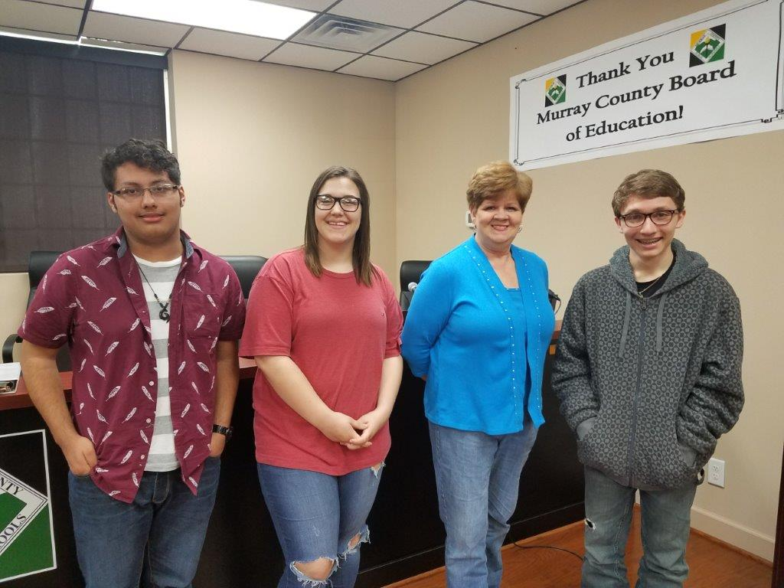

**Opportunities for Meaningful  
Parent Consultation**

Input and suggestions from parents and family members are an essential component of the district and school improvement plans that are developed each year. All parents of students eligible to receive Title I services are invited to attend two meeting opportunities described in this section to share their ideas and suggestions to help the district, schools, and students to reach our student academic achievement goals.

**State of the System Address ~ *January 2018***

All parents are welcome to hear the latest updates from Murray County Schools as well as review and provide input into the district parent and family engagement policy and the Comprehensive LEA Improvement Plan for the 2018-19 school year. Notices regarding this meeting will be shared on social media in advance of the meeting. The district will also communicate information regarding this meeting on the school district website.

**School Improvement Forums ~May *2018***

During this month, each Title I school will host a forum for parents and family members to participate in roundtable discussions to review the schoolwide plan, the school’s parent and family engagement policies as well as provide input on the family engagement budget and programs. Each Title I school will send invitations home and post on social media notifying parents about the date and time of the forum. Information regarding the School Improvement Forum will also be made available on the school websites.

Parent input on the use of Title I funds to support family engagement programs may also be provided through the implementation of a district wide parent advisory council to provide advice on all matters related to parental involvement in Title I, Part A programs. The district will also develop appropriate roles for community-based organizations and businesses, including faith-based organizations, in parental involvement activities.

**Building Capacity**

The Murray County School District will build the schools’ and parents’ capacity for strong parental involvement, to ensure effective involvement of parents and to support a partnership among the schools involved, parents, and the community to improve student academic achievement, through the following activities described below. The school district will, with the assistance of its Title I, Part A schools, aid parents of children served by the school district or school, as appropriate, in understanding topics such as the following, by undertaking the actions described below:

|  |  |
| --- | --- |
| *Georgia’s Academic Content and Achievement Standards* | * *Provide links on the Murray County Schools website and the school websites to the Georgia Department of Education and National PTA publications, presentations, and guides to GA Standards of Excellence;* * *Provide presentations at Curriculum Nights, Math and Reading Nights, Federal Advisory meetings, Local School Council meetings* * *Make available printed copies of documents in school offices;* * *Provide information at Parent-Teacher Conferences* * *Provide trainings throughout the year during Federal Programs Advisory Council meetings and share resources with schools so that they may redeliver the training;* * *Provide resources for circulation in the schools’ Parent-Teacher Resource Room where available;* * *Collaborate with Head Start, Early Head Start, and Georgia Pre-K programs in Murray County to support school readiness and successful Kindergarten transition.* |
| *Georgia and Local Academic Assessments including Alternate Assessments* | * *Provide links to district assessment calendars, study guides for assessments, and guidance concerning testing environments through the district website;* * *Provide links to the District’s Parent Portal and the GaDOE SLDS Dashboard for student profiles and student achievement;* * *Provide links to practice tests for GA Milestones assessments;* * *Provide a Parent Guide to Grading and Reporting;* * *Provide information at Parent-Teacher Conferences;* * *Make available printed copies of documents in school offices.* |
| *Requirements of Title I, Part A* | * *Provide an overview of the requirements of Title I, Part A on the district and school websites and in school newsletters: (1) their child’s school’s participation in Title I, (2) the requirements of Title I, (3) their rights to be involved;* * *Provide an explanation of the requirements at the schools’ Title I Annual Parent Meetings, at other meetings scheduled throughout the year, at Open Houses, at Local School Council meetings, in first day packets.* |
| *How to Monitor Their Child’s Progress* | * *Provide interim reports and report cards on their child’s progress. Dates are posted on the district’s Professional Calendar.* * *Conduct Parent-Teacher Conferences. In addition, parents may request a conference at any time.* * *Provide opportunities at Parent Nights for parents to learn how to access information in Infinite Campus.* * *Provide resources in the district’s Parent Portal.* |
| *How to Work with Educators* | * *Provide opportunities for parents to participate in the development of the school’s School-Parent Compact and Parent Involvement Policy;* * *Provide opportunities for parents to provide feedback in the district’s Parent Needs Assessment;* * *Provide Title I workshops and meetings with school staff.* |

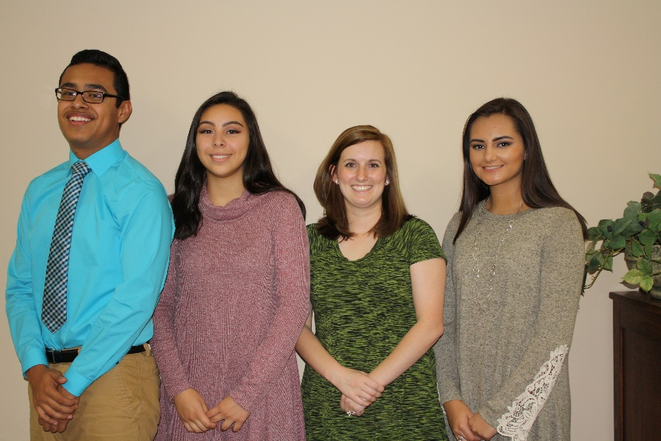

***For Schools***

Welcoming Schools Training

August, 2017 –

County Board Office

**Adoption**

This districtwide parent and family engagement policy has been developed jointly and agreed upon with parents and family members of children participating in Title I, Part A programs as evidenced by the collaboration of parents, school, and district personnel at the annual State of the System Address.

This policy was adopted by Murray County Schools in June 2017 and will be in effect for the 2017-2018 academic school year. The school district will distribute this policy in multiple ways to all parents of participating Title I, Part A children on or before September 1, 2017.

***For Parents***

State of the System Address

January 2018  
NMHS

Annual Parent Survey

April, 2018

School Improvement Forum

May, 2018  
Local school site

District Parent Meeting

June, 2018

County Board Office

**Mark Your Calendars**

**Accessibility**

In carrying out the parent and family engagement requirements established by Section 1116 of the ESSA, district personnel will communicate and collaborate with the Office for Student Support Services and Federal Programs to ensure full opportunities for participation of parents with limited English proficiency, parents with disabilities, and parents of migratory children including providing information and school reports in a language parents can understand.

**Parent and Family Engagement Evaluation**

Each year, MCS will conduct an evaluation of

the content and effectiveness of this parent and family engagement policy and the family engagement activities to improve the academic quality of the Title I schools

through an annual parent climate survey and the

School Improvement Forums.

Beginning in April, each Title I school will send home a survey and email a link to the survey for parents to provide valuable feedback regarding the parent and family engagement activities and programs. These surveys will also be posted on the district and school websites for parents to complete. In addition to the annual survey, each Title I school will also use the School Improvement Forum to facilitate group discussions to discuss the needs parents of children eligible to receive Title I services to design strategies for more effective family engagement.

The MCS will use the findings from the school forums and the survey results to design strategies to improve effective family engagement, to remove possible barriers to parent participation, and to revise its parent and family engagement policies.