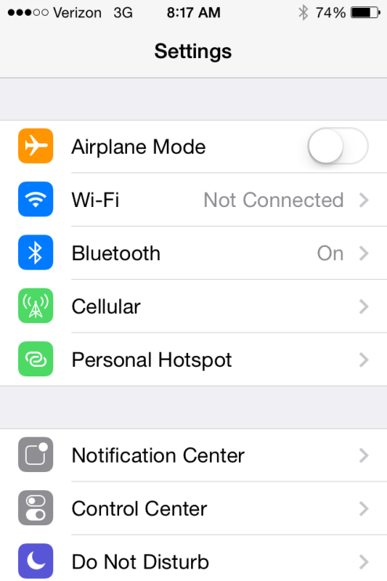 | Navigate to settings and find Wi-Fi
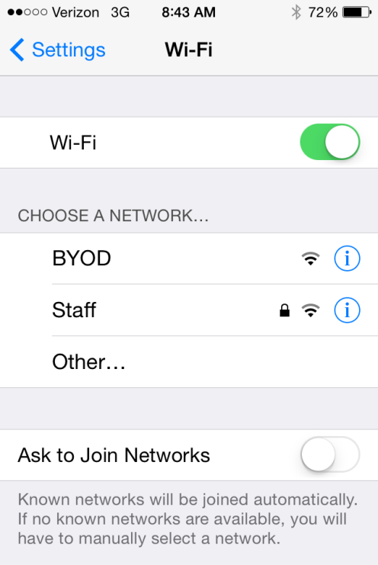 | For students connecting devices, they need to choose BYOD at Aerohive schools.  Non-Aerohive schools will see the same Network choices as you had last year.  Staff – please do not log into “BYOD”. We have so many licenses available to our system. If you want to log into wireless use “Staff”. Username is last name first initial. Password is last four of social.  Example: Username – doej; Password – 1234
 | Use a QR code to scan or open Safari and navigate to https://ds366.awmdm.com/enroll). You should be routed to AirWatch to Authenticate the device by entering the Group ID.
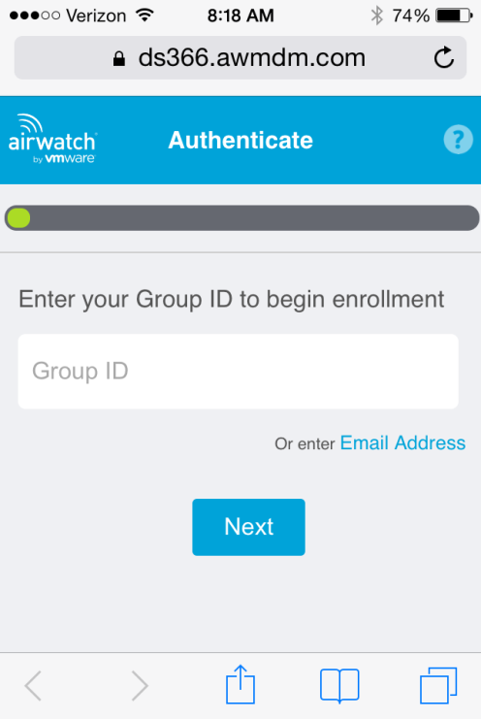 | Enter the group ID provided on the agenda. Use the one that is school specific to you.
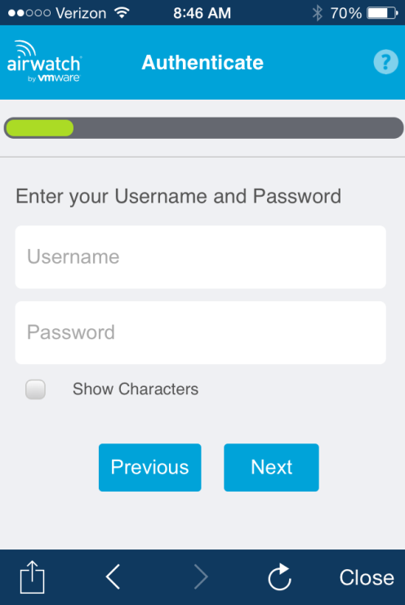 | For grades K – 5, students will use a general login format as if they were logging onto a student computer.  Example: Username – ckeclass; Password – learn  For grades 6 – 12, students will have an assigned login. The username and password are the same. They will login with last name first initial last 4 of social.  Example: doej1234
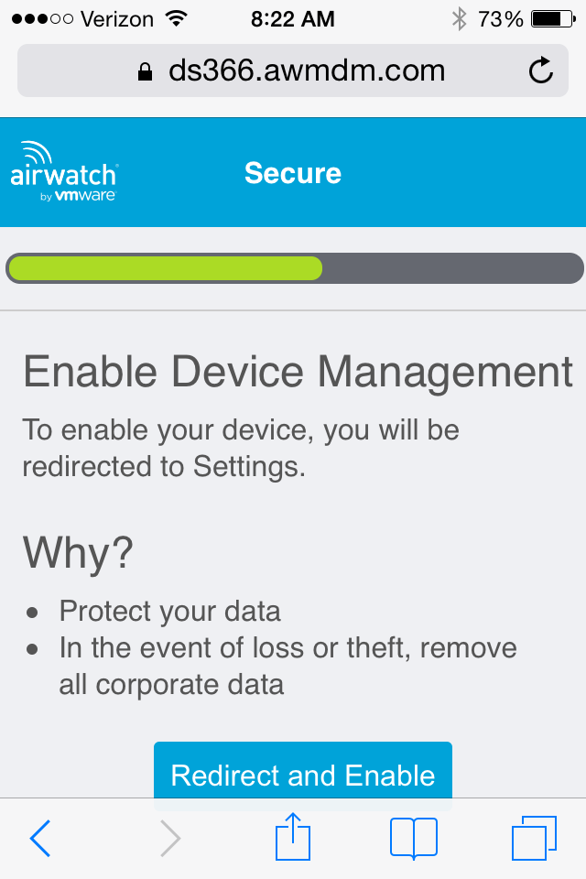 | Select “Redirect and Enable”
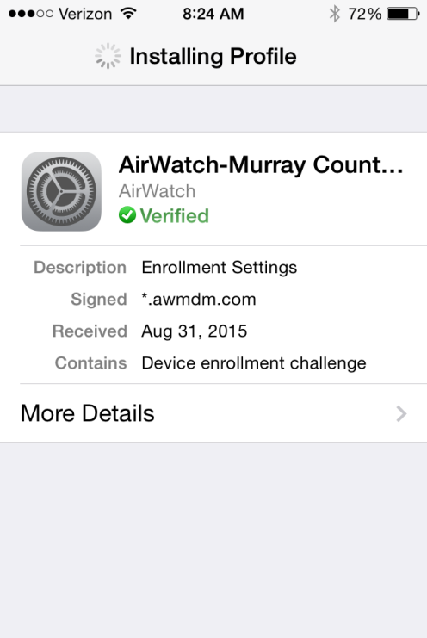 | Installing the Profile will begin at the point. The spinning wheel will appear. Be patient and wait.
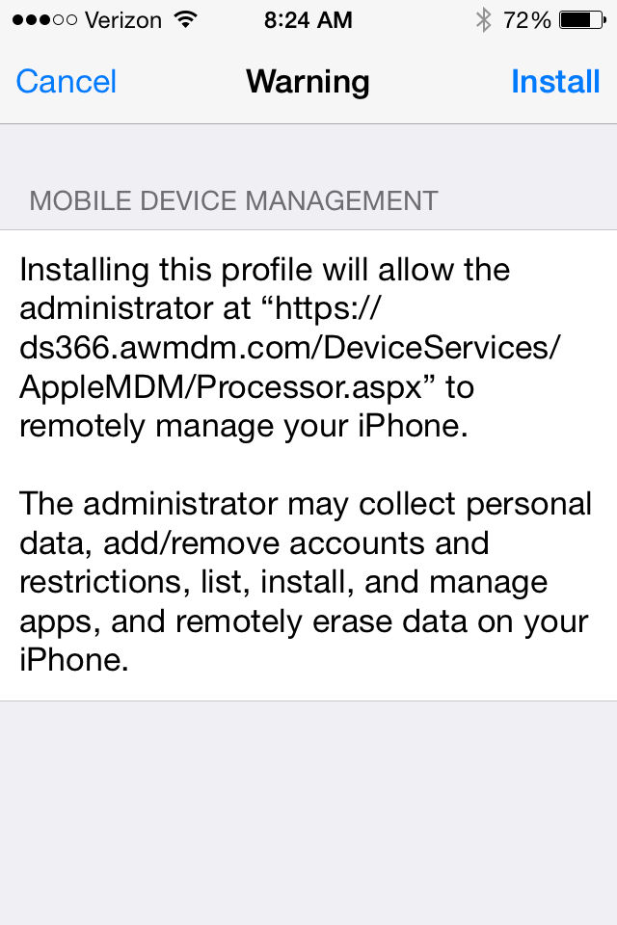 | Select “Install”
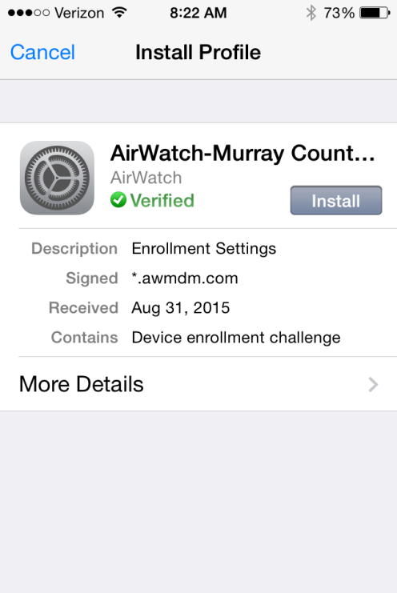 | Select “Install” again
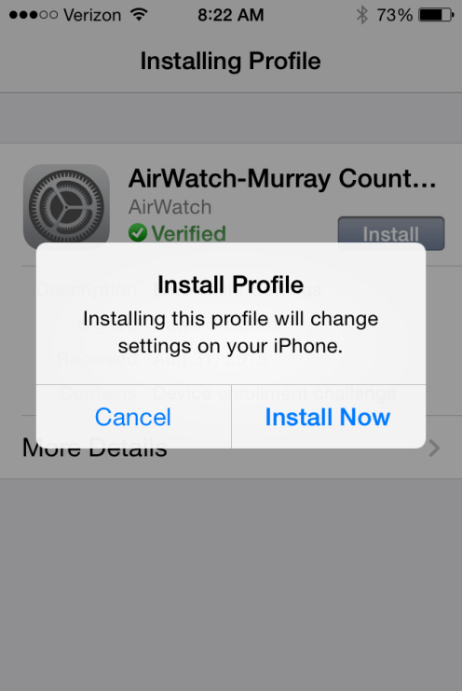 | Select “Install Now”
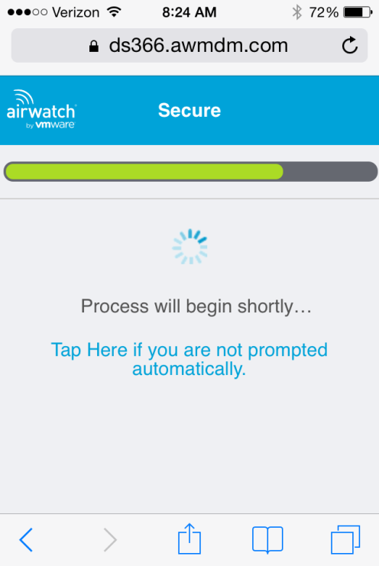 | Again, a spinning wheel will appear. Be patient.
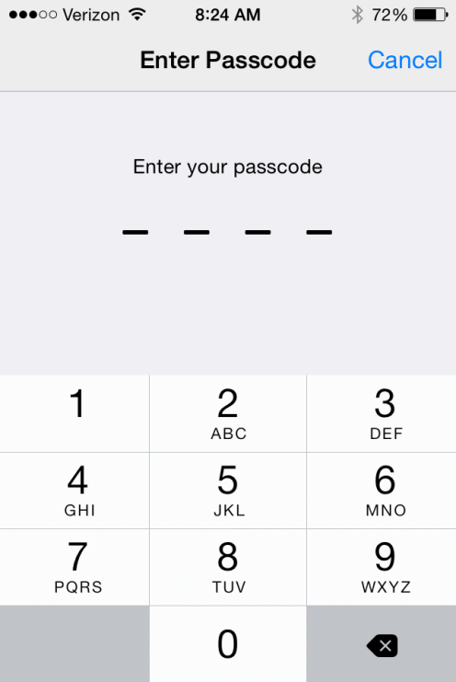 | The device Passcode must be entered to continue.
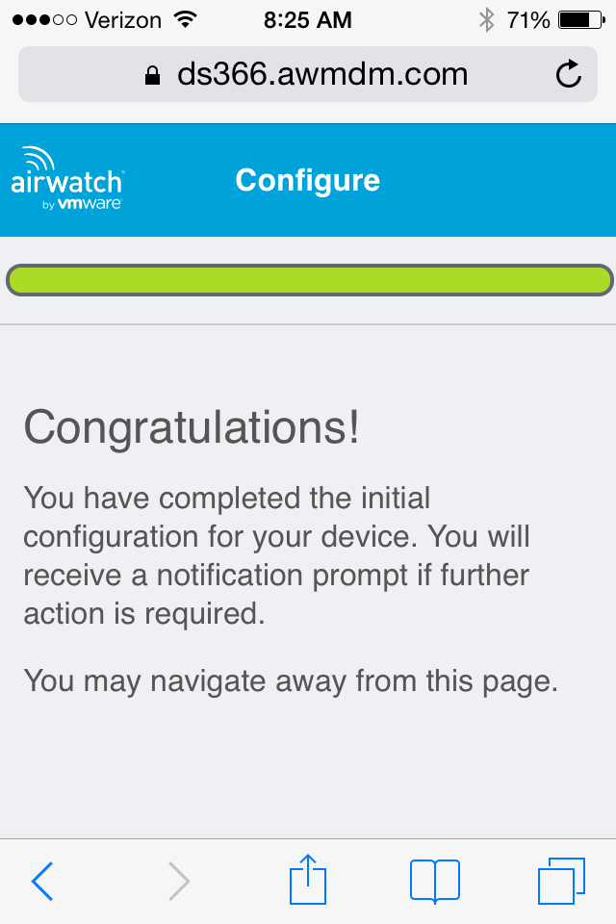 | Once this pops up, the device has been enrolled…but there’s still a few more steps to go.
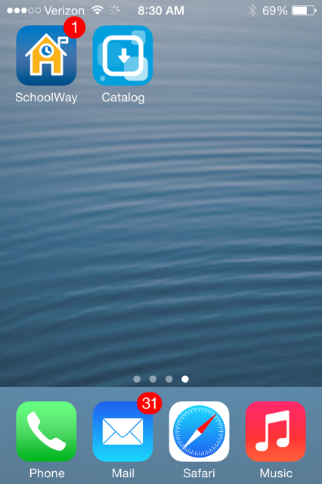 | Once the device is enrolled a “Catalog” will appear on the home page.
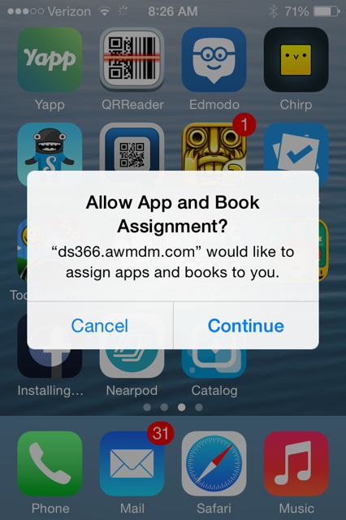 | Select “Continue”
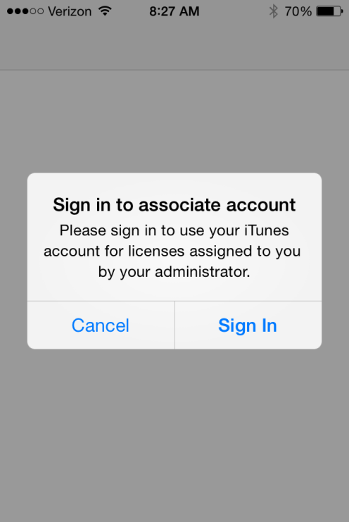 | Select “Cancel”
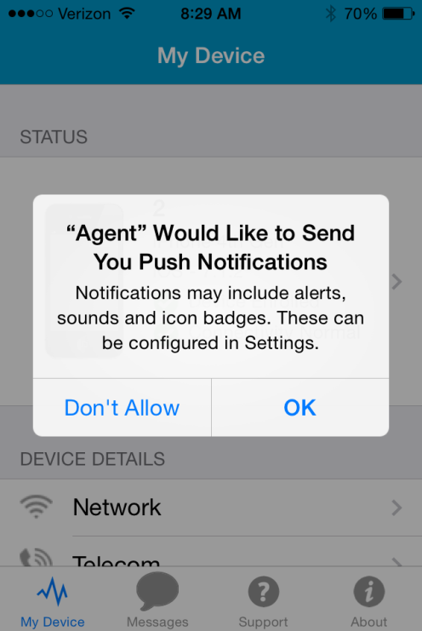 | Select “OK”
 | Once you have enrolled, go back to Settings – WiFi and select “airwatch” network.

